Directions for use of this Worksheet

The purpose of this worksheet is to assist in gathering the information needed to complete the Nomination Appointment form for a patroller being considered for either a National or Leadership Commendation Appointment. The worksheet is designed to assist with questions 6 through 10 of the form. The more you can identify on the worksheet, the more likely the nomination will be approved by Region, Division, and National Award Committees. Samples are available on the web site. (Planned?)

The key to success with these nominations is demonstrated ongoing leadership, not just a flash of leadership. The longer the demonstrated leadership, the better!

Be as specific as possible in the description and information requested. The end date must be a year; it cannot be “present.” List all items in a section from oldest to newest.

The current list of Credentialed programs is:
CPR (American Heart Association, Red Cross or National Safety Council)
Avalanche
Mountain Travel and Rescue
Nordic (? Now a national program again)
Outdoor Emergency Care
Instructor Development
Introduction to Patrolling
Accredited Senior Evaluator (ASE)
PSIA
AASI

These are examples of programs that are NOT credentialed:
Awards
Chair Evacuation
Snowmobile
Patrol Board of Directors
CISM
Newsletter

The letter of recommendation should be brief but complete. It should cross reference supplemental data to the numbered sections on the nomination form. Use the nominees’ full name initially, then use first name or nick name if previously notes. Do not write the letter in third person form. You want to highlight this person accomplishments. Let the reviews know who you are trying to acknowledge.

Please note that as you type in any table, if you pass the end of the space it will expand automatically.

Normally items are listed in an ascending order in section 6, 8, 9 and 10. Ascending order is not a requirement, however consistency in listing items is. List items either ascending or descending in all 4 sections.

6. Must have demonstrated leadership that benefits the NSP
- Beyond the patrol level
Level (Region, Division, National) | Credentialed Program | Demonstrated Leadership | Start Date (Year) | Thru Date (Year)
Here are samples of successful entries for the ”…demonstrate leadership section a. beyond the patrol level” question:
Region OEC IT 20xx 20xx
Region SEM Evaluator 20xx 20xx
Division Nordic Supervisor 20xx 20xx
National OEC New Manual Editor 20xx 20xx

- Or serving two or more ski seasons as a certified instructor in a program beneficial to the NSP
Number of Seasons Served | Course Description | Start Date (Year) | Thru Date (Year)
Include the number of patrollers served when possible. Here are samples of successful entries for the “...demonstrate leadership section b. serving 2 or more years as certified instructor” question:
9 OEC Instructor 19xx 20xx
10 MTR1 and II Instructor 19xx 20xx
3 MTR IT 19xx 20xx
4 Toboggan Instructor 20xx 20xx

Another example on how to present this sections information.
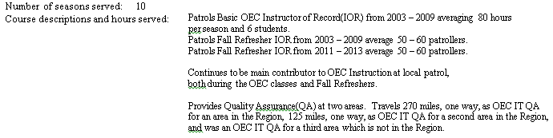

- Or exceptional performance as NSP patrol representative (explain)
Patrol | Exceptional Performance | Start Date (Year) | Thru Date (Year)
Here are samples of successful entries for the “…demonstrate leadership section c. exceptional performance as NSP patrol representative” question:
X has been PR for the Y Patrol for the past 5 years during which the patrol has doubled and become fiscally stable.

7. Patrol Experience (minimum 8 seasons required, 1 season as a senior):
Here are samples of successful entries for the Patrol Experience question:

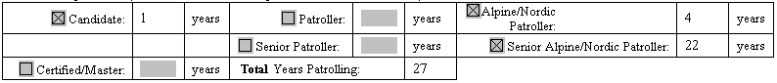
Candidate for 1 year; Alpine/Nordic Patroller for 4 years, Senior Alpine or Nordic for 22 years,
Total 27 years

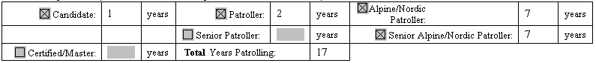Candidate for 1 year; Patroller for 2 years, Alpine/Nordic Patroller for 7 years, Senior Alpine or Nordic for 7 years, Total 17 years

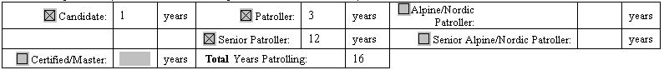
Candidate for 1 year; Patroller for 3 years, Senior for 12 years, Total 16 years, possibly an LCA nomination since without Alpine/Nordic checked the patroller has not passed a skiing evaluation

8. NSP Organization History
Start Date (Year) | Thru Date (Year) | List and describe leadership positions, committee assignments, patrol activities, etc.
Here are samples of successful entries for the NSP Organization History question:
20xx – 20xx OEC Instructor
19xx – 20xx SEM Evaluator
19xx – 20xx Section Chief
19xx – 20xx Division Nordic Ski Enhancement Seminar
19xx – 20xx MTR I and II Instructor
19xx – 20xx Alpine Toboggan Instructor
19xx – 20xx Avalanche Instructor
19xx – 20xx Patrol Team Leader
20xx – Member of planning committee for Central Division meeting
19xx – 20xx Organized and managed patrol on-hill refreshers

9. Skiing public and skier safety education (show lectures, projects, interaction with the skiing public)
Year | Lectures, projects, interactions with the skiing public
Here are samples of successful entries for the Skiing public and skier safety education question:
20xx Participation in trail simulations for Three Rivers Park District
20xx Volunteer Assistant Coach for High School Nordic/Alpine Ski Team
20xx Assist at Nature Center events related to skiing
20xx Lecture at public events at ski area related to skiing safety
20xx Work at disabled skier events at ski area

10. NSP Awards
Year | Award
Here are samples of successful entries for the NSP Awards question:
20xx Yellow Merit star,
20xx Outstanding Awards (patroller, service, instructor, etc.) from patrol, region, division, and/or national level,
20xx Program Awards,
20xx Certificates of Appreciation,
20xx Distinguished Service Award,
20xx local patrol awards.

